Infosys Springboard Virtual Internship 6.0 Completion Report

Team Details <Do not mention any personally identifiable information like email ID, institute details, mobile phone number etc.>

Batch Number: 1 BudgetWise AI based Expense Forecasting Tool
Start date : 13-08-2025
Names:

Internship Duration: 8 Weeks

1. Project Title
BudgetWise AI based Expense Forecasting Tool

2. Project Objective

BudgetWise is an AI-driven expense forecasting tool designed to help individuals and businesses manage their finances more effectively. By leveraging machine learning algorithms, it analyzes historical spending patterns and predicts future expenses with high accuracy, considering factors such as income, lifestyle, and seasonal trends. The tool provides personalized budgeting recommendations and visualizes forecasts through interactive dashboards and charts. It also generates timely alerts and insights to prevent overspending, while seamlessly integrating with banking and financial apps for real-time data synchronization. As new spending data is added, the AI engine continuously adapts to improve predictions. Supporting multiple user profiles, BudgetWise caters to individuals, families, and small businesses alike. Ultimately, it empowers users to make smarter financial decisions, optimize budgeting, and cultivate better savings habits.

3. Project description in detail
BudgetWise is an innovative AI-powered expense forecasting tool developed to address the growing need for smarter financial management among individuals, families, and businesses. The project leverages machine learning (ML) and artificial intelligence (AI) to analyze users’ historical spending data, identify recurring patterns, and provide accurate predictions for future expenses. By offering intelligent insights, the tool empowers users to plan budgets more effectively, reduce unnecessary spending, and improve long-term savings habits.
The system works by integrating with bank accounts, digital wallets, and financial applications to gather real-time income and expenditure data. Using advanced algorithms, BudgetWise classifies expenses into categories such as housing, food, transportation, healthcare, and entertainment. It then applies predictive modeling techniques to estimate future spending, while considering seasonal variations, lifestyle changes, and inflationary effects.
One of the core features of BudgetWise is its interactive dashboard, which presents financial insights through easy-to-understand charts, graphs, and visual reports. The tool also includes personalized alerts and recommendations to notify users about overspending trends, upcoming bills, and opportunities to save. For businesses, the system can forecast operational costs, employee expenses, and cash flow trends, enabling more strategic financial planning.
Additionally, BudgetWise supports multi-user profiles, making it suitable for individuals, families managing shared budgets, and small-to-medium enterprises (SMEs). Its self-learning AI engine continuously improves accuracy as it processes more data, adapting to changing user behaviors and financial goals.
Overall, the project aims to create a comprehensive digital finance assistant that not only forecasts expenses but also educates users in financial discipline. By combining predictive analytics with user-friendly interfaces, BudgetWise bridges the gap between technology and personal finance, helping users achieve financial stability and smarter decision-making in an increasingly data-driven world.
4. Timeline Overview
Week | Activities Planned | Activities Completed
Week 1 | Requirement gathering, project scope definition, and resource allocation | Requirements finalized, project scope documented, team roles assigned
Week 2 | Research on AI/ML models for expense forecasting and selection of development tools/tech stack | Suitable ML algorithms shortlisted (e.g., ARIMA, LSTM), tech stack finalized (Python, Flask/Django, React, SQL)
Week 3 | Database design and setup for income/expense data | Database schema created and tested with sample datasets
Week 4 | Data collection, preprocessing, and integration with dummy financial data | Historical expense dataset collected, cleaned, and categorized
Week 5 | Model development: Training AI/ML algorithms on expense forecasting | Initial ML models trained and tested for accuracy with validation datasets
Week 6 | Development of user interface (dashboard, charts, visualization) | Prototype dashboard built with charts for expense categories and forecasts
Week 7 | System integration: Linking AI model, database, and UI | Integrated model with UI, enabled real-time forecasting and alerts
Week 8 | Testing, debugging, documentation, and final project deployment | Functional testing completed, bugs fixed, user guide prepared, project deployed successfully

5a. Key Milestones
Milestone | Description | Date Achieved
Project Kickoff | Project kickoff defined objectives, scope, and roles. | 13 – Aug - 2025
Prototype/First Draft | Developed the prototype for resume matching and skill recommendation. | 28 - Aug - 2025
Mid-Term Review | Completed mid-term review to assess progress and refine project approach. | 11 - Sep - 2025
Final Submission | Submitted the completed Budgetwise project with full functionality and documentation. | 26 - Sep - 2025
Presentation | Prepared and delivered the project presentation showcasing features and outcomes. | 10 - Oct - 2025

5b. Project execution details

• Requirement Analysis – Gathered user needs, defined project scope, and finalized objectives.
• Technology Selection – Chose AI/ML models (ARIMA, LSTM), Python for backend, React for frontend, and SQL for database.
• System Design – Designed database schema, workflow diagrams, and UI mockups.
• Data Collection – Gathered historical financial datasets and created dummy records for testing.
• Data Preprocessing – Cleaned, categorized, and structured data for ML training.
• Model Development – Trained forecasting models, evaluated accuracy, and implemented self-learning mechanisms.
• Frontend Development – Built interactive dashboards with charts, spending alerts, and reports.
• Backend Development – Developed APIs, linked ML models with UI, and integrated financial APIs.
• Testing & Integration – Conducted unit, system, and user acceptance testing; resolved bugs.
• Deployment & Documentation – Deployed the tool on cloud, prepared user manual, and presented final demo.

6. Snapshots / Screenshots
Step 1 : Go to Github and clone the Repository in your system then open in VS Code to do the execution , here is the github repo link : ANINDASAU/Budgetwise-Forcasting-Infosys
Step 2 : Start the with python app.py
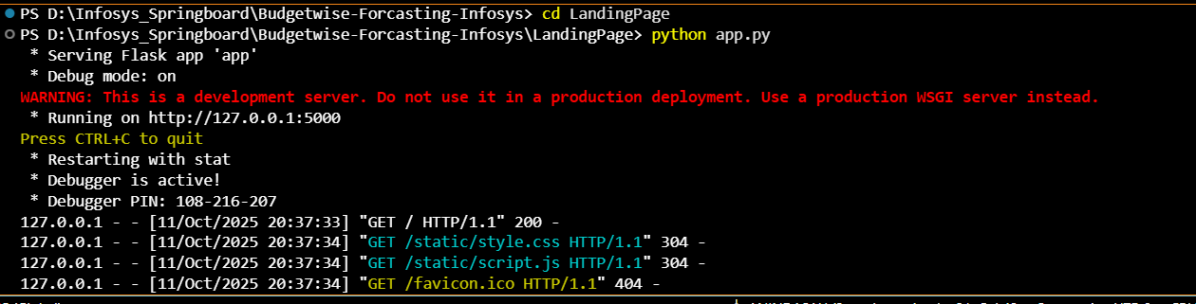

Step 3: Here is the Landing page with basic navigation and a chatbot for helping user
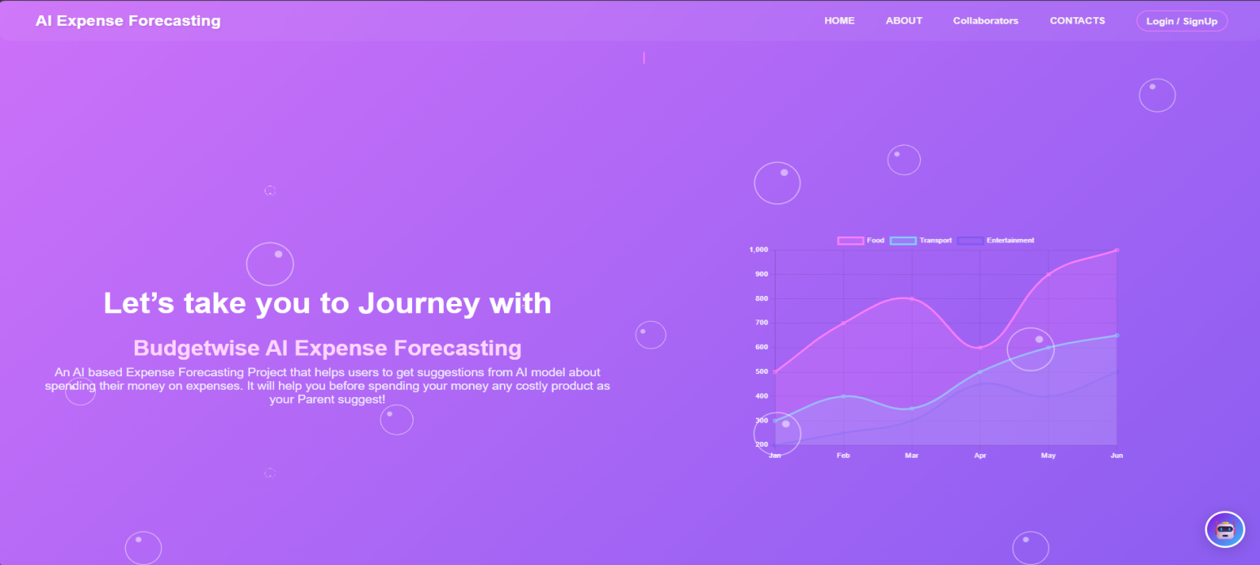

Step 4: After clicking on Login/Signup here user need to register and log in for Authentication.
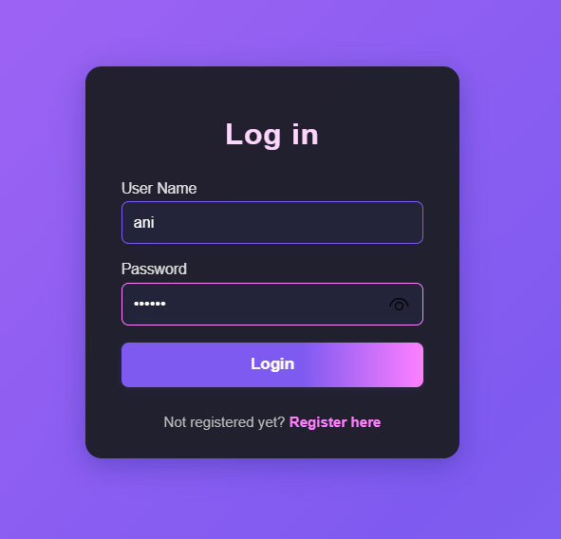
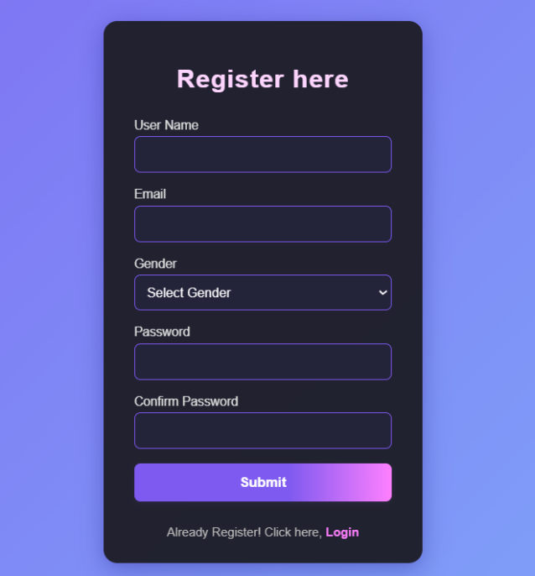

Step 5: User need to put their Details of budget and expenses.
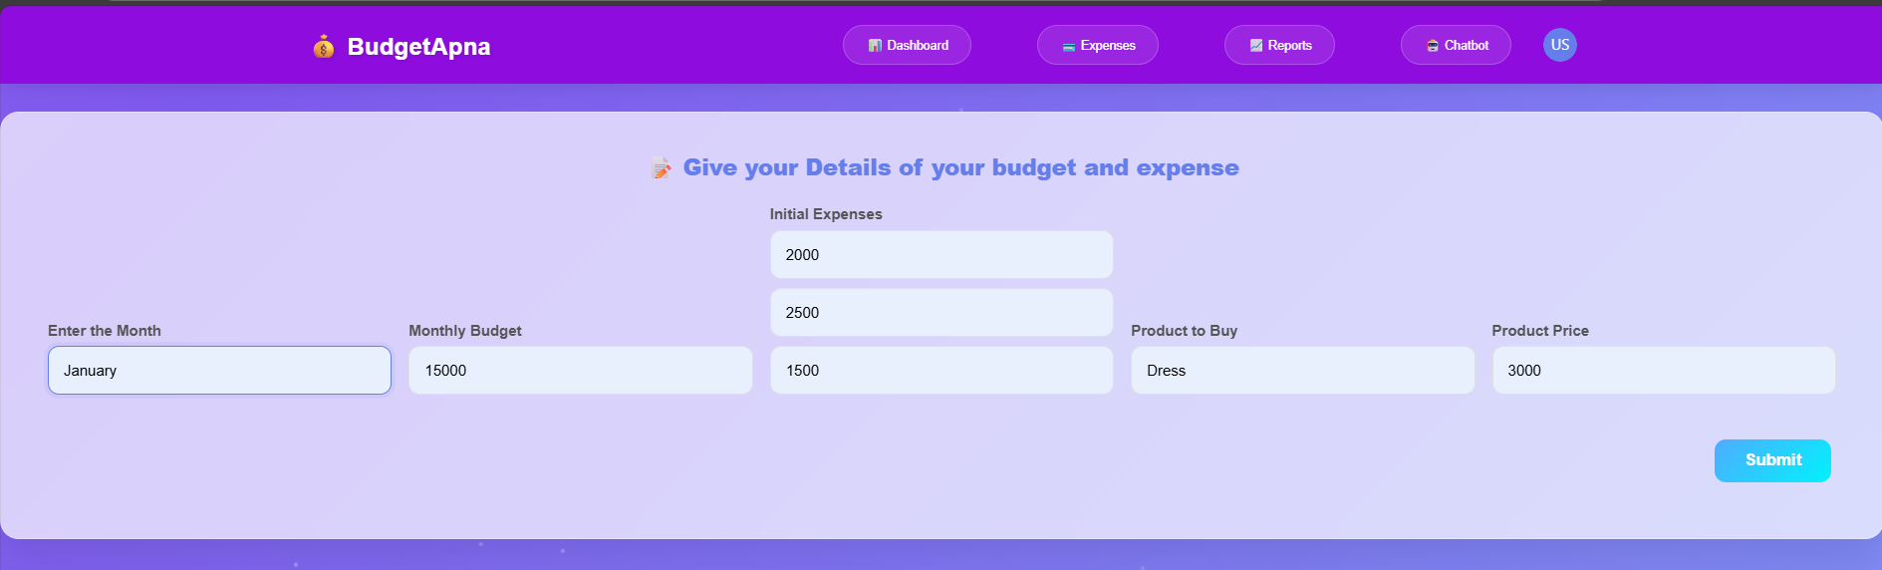

Step 6: After submitting user input it showcase the basic data on as a dashboard.
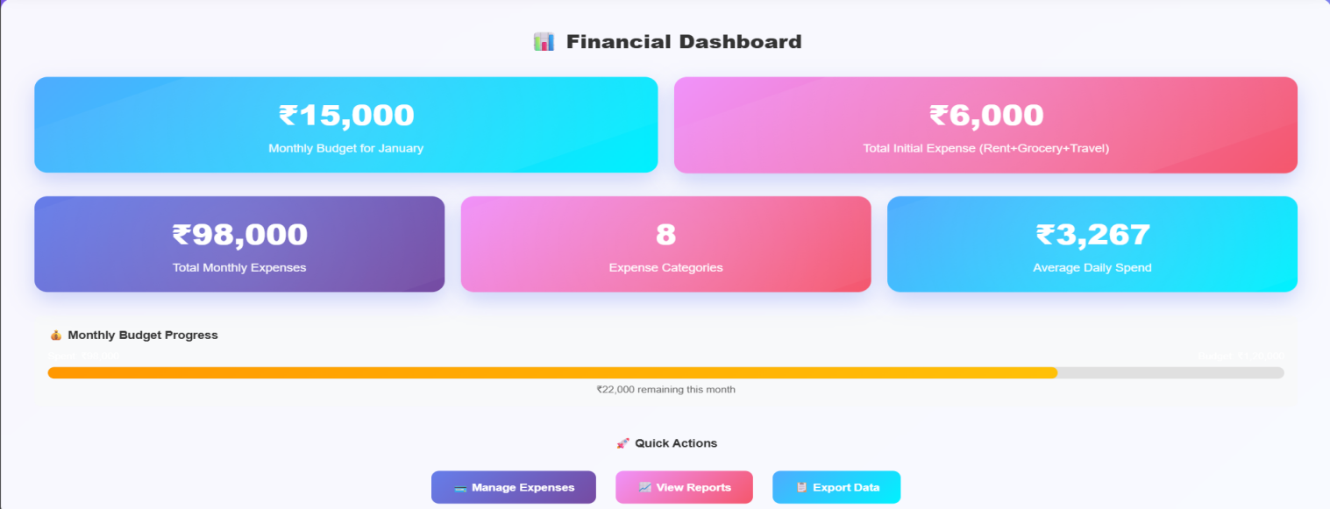

Step 7: In these Expense tab user can add new expense like food, transport and others.
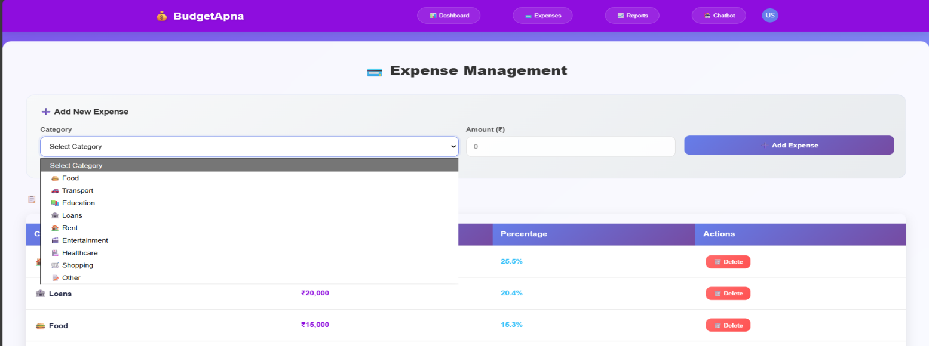

Step 8: Here is the details of add expense dashboard
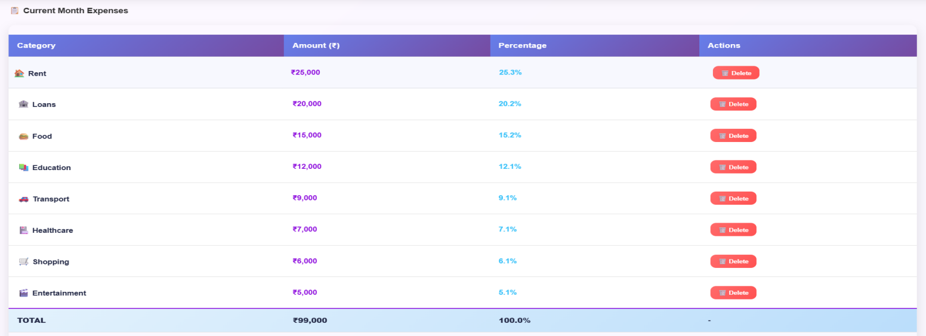

Step 9: Here is basic report also with graph and charts.
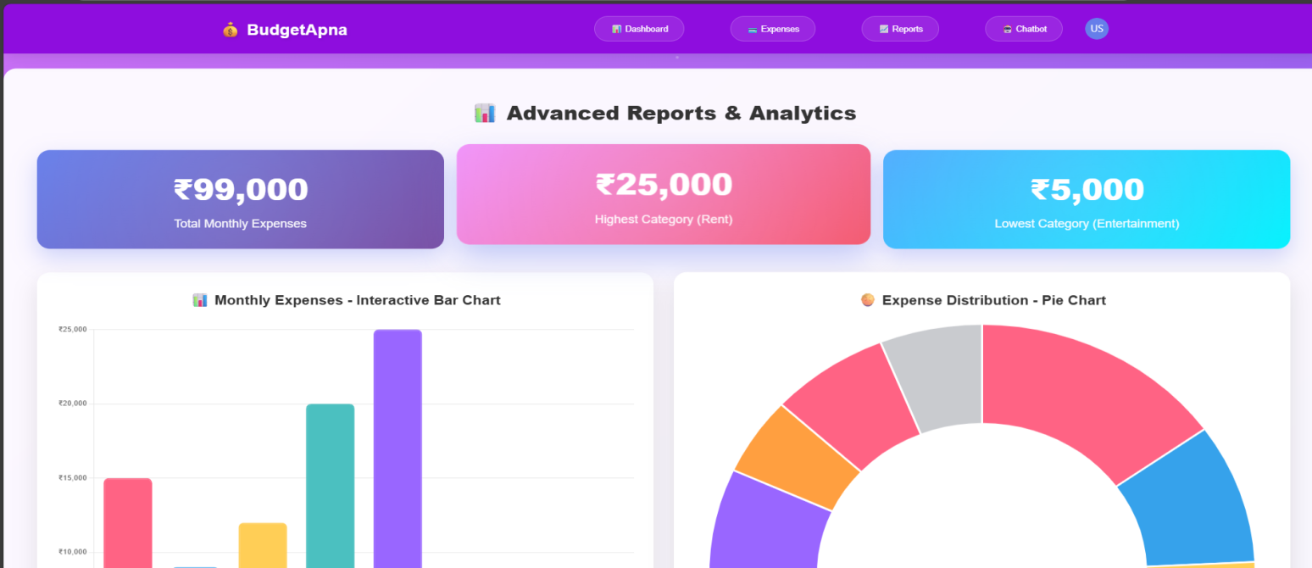

Step 10: Using this you can generate report as pdf.
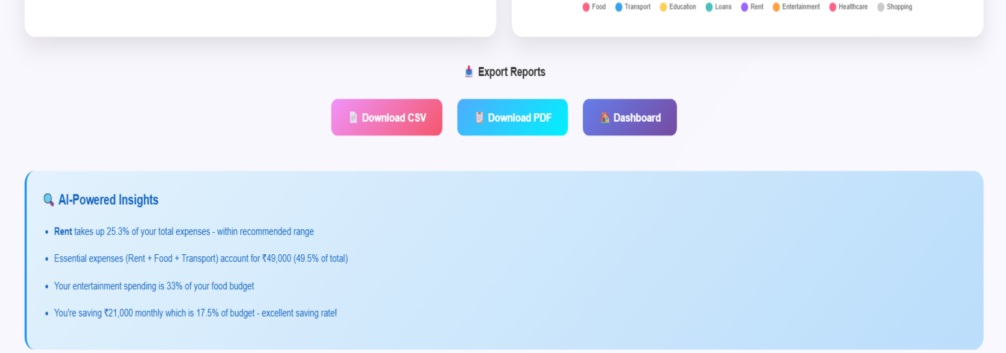

Step 11: Report look like this
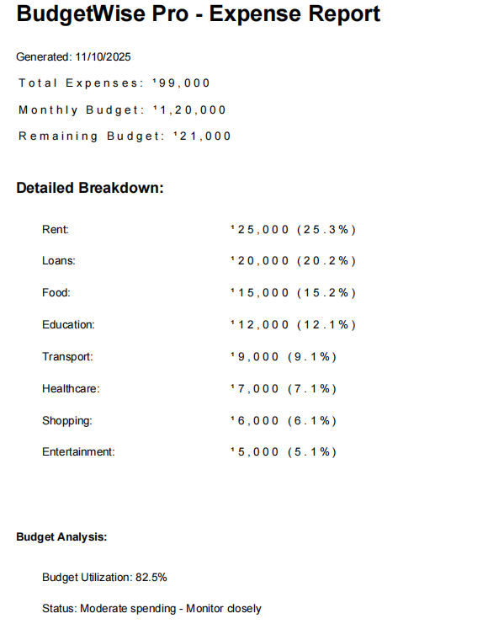

Step 12: Using Chatbot user can communicate with Chatbot
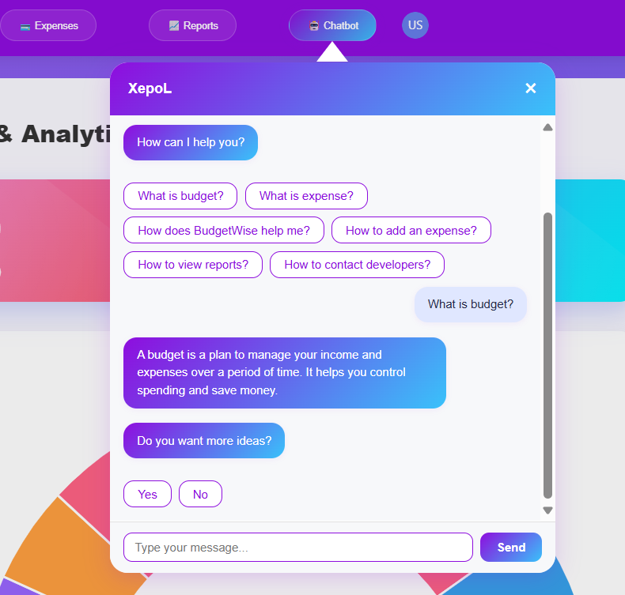

End : Finally here is the Contact section to communicate with collaborators.
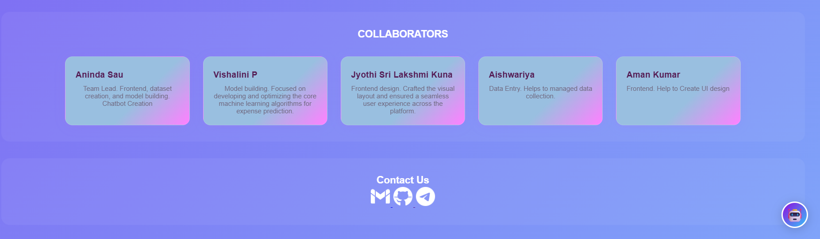

7. Challenges Faced
• Data Availability – Obtaining real-world financial datasets was difficult, requiring reliance on simulated or open-source data.
• Data Quality Issues – Inconsistent, missing, and unstructured data needed heavy preprocessing before use.
• Model Accuracy – Achieving high accuracy in expense forecasting was challenging due to unpredictable spending patterns.
• Algorithm Selection – Choosing the right ML model (ARIMA vs LSTM vs Regression) required multiple trials and evaluations.
• Integration Complexity – Linking AI models with the backend, database, and frontend created synchronization issues.
• Real-Time Updates – Handling live financial data and ensuring real-time forecasts without performance lag was a challenge.
• User Interface Design – Creating a simple yet feature-rich dashboard to cater to both individuals and businesses took iterations.
• Security Concerns – Ensuring data privacy and secure integration with financial apps was critical.
• Time Management – Balancing all phases (data, ML, frontend, backend, testing) within the 8-week timeline was demanding.
• Testing & Validation – Validating predictions across multiple user profiles and expense categories required extensive testing.

8. Learnings & Skills Acquired

• AI & Machine Learning Knowledge – Gained hands-on experience in applying algorithms like ARIMA, LSTM, and regression for financial forecasting.
• Data Handling Skills – Improved ability to collect, clean, preprocess, and analyze large datasets effectively.
• Time-Series Analysis – Learned techniques for predicting trends based on historical financial data.
• Full-Stack Development – Enhanced skills in backend (Python, Flask/Django), frontend (React.js), and database (MySQL/PostgreSQL) integration.
• Visualization & Reporting – Developed interactive dashboards using Plotly/Matplotlib to present forecasts clearly.
• Problem-Solving Abilities – Tackled challenges like inconsistent data, integration issues, and model optimization.
• Cloud Deployment – Learned to deploy AI-powered applications on cloud platforms for real-time accessibility.
• Collaboration & Teamwork – Strengthened coordination through Agile methodology, weekly sprints, and feedback sessions.
• Testing & Debugging – Improved skills in unit testing, integration testing, and user acceptance testing (UAT).
• Financial Domain Knowledge – Understood budgeting, expense categorization, and financial planning strategies.

9. Testimonials from team
Team Member 1:
"This project enhanced my understanding of machine learning models for text similarity and helped me learn how to extract meaningful insights from unstructured data."

Team Member 2:
"I gained hands-on experience in resume parsing, skill recommendation systems, and building interactive dashboards, which strengthened both my technical and practical skills."

Team Member 3:
"SkillMatch taught me how to work collaboratively, manage project timelines, and integrate AI solutions into a functional web application."

Team Member 4:
"The project improved my knowledge in NLP, data preprocessing, and visualization techniques, and also boosted my confidence in handling real-world AI applications."

10. Conclusion

The BudgetWise project successfully developed an AI-based tool for accurate expense forecasting and smart financial planning. It combines machine learning, data analysis, and interactive dashboards to help users manage budgets, track spending, and make informed decisions. The project enhanced technical skills, problem-solving, and teamwork, while delivering a user-friendly system that promotes better financial habits.

11. Acknowledgements
Thank the organization, mentor, and any team members who supported your internship journey.
I would like to express my sincere gratitude to Infosys for providing me the opportunity to work on the BudgetWise AI based Expense Forecasting Tool project and gain hands-on experience in AI and ML applications.
I am especially thankful to my mentor, Sangeetha, for their constant guidance, support, and valuable insights throughout the internship. Their mentorship helped me overcome challenges and grow both technically and professionally.
I would also like to thank my team members for their collaboration, encouragement, and efforts in successfully executing this project. Their teamwork made the internship journey smooth and enriching.
Finally, I appreciate everyone who contributed directly or indirectly to my learning and the completion of this project.

